**20.Create an simple application using AJAX to show the table of numbers given by user at runtime.**

CODE:html

File-name: code-20.html

<!DOCTYPE html>

<html>

<head>

    <title>Number Table</title>

    <script src="https://ajax.googleapis.com/ajax/libs/jquery/3.6.0/jquery.min.js">

</script>

    <script src="code-20.js"></script>

</head>

<body>

    <h1>Number Table</h1>

    <form id="number-form">

    <label for="number-list">Enter a list of numbers, separated by commas:</label><br>

        <input type="text" id="number-list" name="number-list"><br>

        <input type="submit" value="Generate Table">

    </form>

    <div id="table-container"></div>

</body>

</html>

Js code:

File-name: code-20.js

$(document).ready(function() {

    $("#number-form").submit(function(event) {

        event.preventDefault();

        var numbers = $("#number-list").val();

        $.ajax({

            url: "code-20.php",

            method: "POST",

            data: { numbers: numbers },

            success: function(result) {

                $("#table-container").html(result);

            }

        });

    });

});

Php code:

File-name: code-20.php

<?php

if (isset($_POST["numbers"])) {

    $numbers = explode(",", $_POST["numbers"]);

    $table = "<table>";

    foreach ($numbers as $number) {

        $table .= "<tr><td>" . $number . "</td><td>" . ($number * $number) . "</td></tr>";

    }

    $table .= "</table>";

    echo $table;

}

?>

NOTE: Run in browser url

localhost/foldername/code-20.html

OUTPUT:

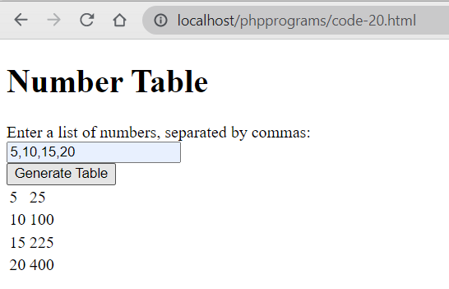

**21. Access web service using Ajax and handle using JSON.**

Ajax with Jquery is very useful for send and received data to server without refresh of web page. So by using Ajax here we have send request to PHP script for received data in JSON and displaying that data on web page. If you have used Ajax for your application then in it will received in data in many formats like text, html, json etc. But in all of then JSON datatype is a very lightweight in sending and receiving data from server and it will increase the execution speed of your web application.  
  
In this post we will discuss seen how can we send Ajax request to PHP script for receiving data in JSON format and by using Jquery we will display that data on webpage without refresh of web page. By using this type of data type you can exchange large amount of data without waiting of time.

**CODE:js-----**

**save file name as code-21.js**

$(document).ready(function() {

    $("#get-data").click(function() {

        $.ajax({

            url: "https://jsonplaceholder.typicode.com/posts",

            method: "GET",

            dataType: "json",

            success: function(result) {

                var data = "";

                $.each(result, function(index, post) {

                    data += "<h2>" + post.title + "</h2><p>" + post.body + "</p>";

                });

                $("#data-container").html(data);

            }

        });

    });

});

**CODE:js-----**

**Save file name as code-21.php:**

<!DOCTYPE html>

<html>

<head>

    <title>Web Service Example</title>

    <script src="https://ajax.googleapis.com/ajax/libs/jquery/3.6.0/jquery.min.js"></script>

    <script src="code-21.js"></script>

</head>

<body>

    <h1>Web Service Example</h1>

    <button id="get-data">Get Data</button>

    <div id="data-container"></div>

</body>

</html>

**Output: click on get data button ,then after you will get data.**

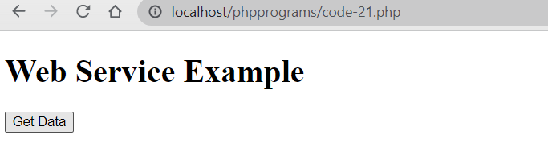

**22. Create a responsive website using bootstap.**

 A responsive website can be divided into five major components. As we are building a responsive website, the main components are as follows.

1. Navigation  
2. Information area  
3. Contents section  
4. Right Sidebar  
5. Footer.

CODE:

<!DOCTYPE html>

<html>

<head>

<meta name="viewport" content="width=device-width, initial-scale=1.0">

<style>

* {

  box-sizing: border-box;

}

.row::after {

  content: "";

  clear: both;

  display: table;

}

[class*="col-"] {

  float: left;

  padding: 15px;

}

html {

  font-family: "Lucida Sans", sans-serif;

}

.header {

  background-color: #9933cc;

  color: #ffffff;

  padding: 15px;

}

.menu ul {

  list-style-type: none;

  margin: 0;

  padding: 0;

}

.menu li {

  padding: 8px;

  margin-bottom: 7px;

  background-color: #33b5e5;

  color: #ffffff;

  box-shadow: 0 1px 3px rgba(0,0,0,0.12), 0 1px 2px rgba(0,0,0,0.24);

}

.menu li:hover {

  background-color: #0099cc;

}

.aside {

  background-color: #33b5e5;

  padding: 15px;

  color: #ffffff;

  text-align: center;

  font-size: 14px;

  box-shadow: 0 1px 3px rgba(0,0,0,0.12), 0 1px 2px rgba(0,0,0,0.24);

}

.footer {

  background-color: #0099cc;

  color: #ffffff;

  text-align: center;

  font-size: 12px;

  padding: 15px;

}

/* For mobile phones: */

[class*="col-"] {

  width: 100%;

}

@media only screen and (min-width: 600px) {

  /* For tablets: */

  .col-s-1 {width: 8.33%;}

  .col-s-2 {width: 16.66%;}

  .col-s-3 {width: 25%;}

  .col-s-4 {width: 33.33%;}

  .col-s-5 {width: 41.66%;}

  .col-s-6 {width: 50%;}

  .col-s-7 {width: 58.33%;}

  .col-s-8 {width: 66.66%;}

  .col-s-9 {width: 75%;}

  .col-s-10 {width: 83.33%;}

  .col-s-11 {width: 91.66%;}

  .col-s-12 {width: 100%;}

}

@media only screen and (min-width: 768px) {

  /* For desktop: */

  .col-1 {width: 8.33%;}

  .col-2 {width: 16.66%;}

  .col-3 {width: 25%;}

  .col-4 {width: 33.33%;}

  .col-5 {width: 41.66%;}

  .col-6 {width: 50%;}

  .col-7 {width: 58.33%;}

  .col-8 {width: 66.66%;}

  .col-9 {width: 75%;}

  .col-10 {width: 83.33%;}

  .col-11 {width: 91.66%;}

  .col-12 {width: 100%;}

}

</style>

</head>

<body>

<div class="header">

  <h1>CENTURION UNIVERSITY</h1>

</div>

<div class="row">

  <div class="col-3 col-s-3 menu">

    <ul>

      <li>Domain Courses</li>

      <li>Skill Courses</li>

      <li>CSR Activities</li>

      <li>Courseware</li>

      <li>ERP</li>

    </ul>

  </div>

  <div class="col-6 col-s-9">

    <h1>The CUTMAP</h1>

    <p>CENTURION UNIVERSITY IS THE BEST PRIVATE UNIVERSITY IN VIZIANAGARAM.</p>

  </div>

  <div class="col-3 col-s-12">

    <div class="aside">

      <h2>What?</h2>

      <p>CUTMAP IS A SKILLED UNIVERSITY.</p>

      <h2>Where?</h2>

      <p>IT IS LOCATED IN VIZIANAGARAM,ANDHRA PRADESH.</p>

      <h2>How?</h2>

      <p>YOU CAN REACH BY DIFFERENT WAYS.......</p>

    </div>

  </div>

</div>

<div class="footer">

  <p>Resize the browser window to see how the content respond to the resizing.</p>

</div>

</body>

</html>

OUTPUT:



23.Develop student registration web application using PHP.

Code:

<!DOCTYPE html>

<html >

<head>

<title>Registration Form</title>

<style> input,textarea{width:200px}

input[type=radio],input[type=checkbox]{width:10px} input[type=submit],input[type=reset]{width:100px}

</style>

</head>

<body>

    <h1>Student Registration Form </h1>

<form method="post" enctype="multipart/form-data">

<table width="393" border="1">

<tr>

<td colspan="2"><?php echo @$msg; ?></td>

</tr>

<tr>

<td width="159">Enter your Name</td>

<td width="218">

<input type="text" placeholder="your first name" name="n" pattern="[a-z A- Z]*" required /></td>

</tr>

<tr>

<td>Enter your Email</td>

<td><input type="email" name="e"/></td>

</tr>

<tr>

<td>Enter your Password</td>

<td><input type="password" name="p"/></td>

</tr>

<tr>

<td>Enter your Address</td>

<td><textarea name="add"></textarea></td>

</tr>

<tr>

<td>Enter your Mobile</td>

<td><input type="text" pattern="[0-9]*" name="m" /></td>

</tr>

<tr>

<td height="23">Select your Gender</td>

<td>

Male<input  type="radio" name="g" value="m"/> Female<input type="radio" name="g" value="f"/>

</td>

</tr>

<tr>

<td>Choose your Hobbies</td>

<td>

Cricket<input type="checkbox" value="cricket" name="hobb[]"/>

Singing<input type="checkbox" value="singing" name="hobb[]"/>

Dancing<input type="checkbox" value="dancing" name="hobb[]"/>

</td>

</tr>

<tr>

<td>Choose your Profile Pic </td>

</td>

</tr>

<tr>

<td>Choose your Profile Pic </td>

<td><input type="file" name="pic"/></td>

</tr>

<tr>

<td>Select your DOB</td>

<td>

<select name="mm">

<option value="">Month</option>

<?php for($i=1;$i<=12;$i++)

{

echo "<option value='$i'>".$i."</option>";

}

?>

</select>

<select name="dd">

<option value="">Date</option>

<?php for($i=1;$i<=31;$i++)

{

echo "<option value='$i'>".$i."</option>";

}

?>

</select>

<select name="yy">

<option value="">Year</option>

<?php for($i=1900;$i<=2015;$i++)

{

echo "<option value='$i'>".$i."</option>";

}

?>

OUTPUT:

